Curriculum Vitae
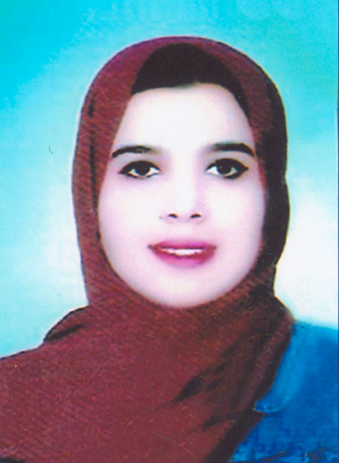

Name: Aya Mamdouh Soliman Younis

Nationality: Egyptian

Sex: Female

Date of Birth: January 26th, 1994

Place of Birth: Aswan, Egypt

Marital Status: Single

Contact Address: Department of Medicinal Chemistry, Faculty of Pharmacy, Assiut University, Assiut, Egypt

Cell Phone Number: +201102065703

E-mail: Ayamamdouh26194@gmail.com
aya.mamdouh@pharm.aun.edu.eg

Languages: fluent in Arabic and English

Education:
- Bachelor of Pharmaceutical Sciences, June 2017, Assiut University, Egypt.
Grade: Excellent with Honors.

Academic Positions
March 2019 - | Demonstrator at Department of Medicinal Chemistry, Faculty of Pharmacy, Assiut University, Assiut, Egypt.

Computer skills:
- Microsoft office word
- Power-point
- Excel
- Access
- Internet

